OLED 0.96-inch Display Module + Circuit Explanation
This system uses an OLED 0.96-inch display to show relevant information. In mainstream stereoscopic displays, a special parallax grating is placed between the backlight source and the LCD panel. Based on the same principle, this stereoscopic display technology can also be applied to OLED displays. The basic function of parallax illumination is to send the images corresponding to the odd and even pixel columns of the OLED screen into the observer's left and right eyes respectively, thereby separating the images and producing a stereoscopic effect. OLED, or Organic Light-Emitting Diode, is also known as Organic Electroluminescence Display (OELD). Because it is thin, lightweight, and power-saving, it has many advantages over LCD. With its self-emissive nature, no backlight requirement, high contrast, thin profile, wide viewing angle, fast response speed, suitability for flexible panels, and relatively simple structure and manufacturing process, it is regarded as an emerging next-generation flat-panel display technology.
LCDs require backlighting, but OLEDs do not because they are self-emissive. Therefore, for the same display content, OLED generally produces better visual results. With current technology, it is still difficult to make OLED displays very large, but high resolution can be achieved. Here we use a 0.96-inch OLED display, which has the following features:
1) The 0.96-inch OLED is available in yellow-blue, white, and blue. In the yellow-blue version, the upper one-quarter of the screen emits yellow light and the lower three-quarters emit blue light. The display colors and regions are fixed and cannot be changed. The white version displays white on a black background, and the blue version displays blue on a black background. In this design, a yellow-blue dual-color OLED display is selected.
2) Resolution: 128 x 64.
3) Multiple interface modes. The OLED bare screen supports five interface types in total: 6800 and 8080 parallel interfaces, 3-wire or 4-wire serial SPI interfaces, and IIC interface mode. These five interfaces are configured through BS0-BS2 on the screen.
- Module Pin Description
(1) GND: power ground
(2) VCC: positive power supply (3-5.5V)
(3) D0: OLED D0 pin, used as the clock pin in SPI and IIC communication
(4) D1: OLED D1 pin, used as the data pin in SPI and IIC communication
(5) RES: OLED RES# pin, used for reset (active low reset)
(6) D/C: OLED D/C#E pin, data and command control pin
(7) CS: OLED CS# pin, that is, the chip-select pin
The module interface schematic is shown below.
Sensor interface circuit schematic
The physical picture of the module is shown below.
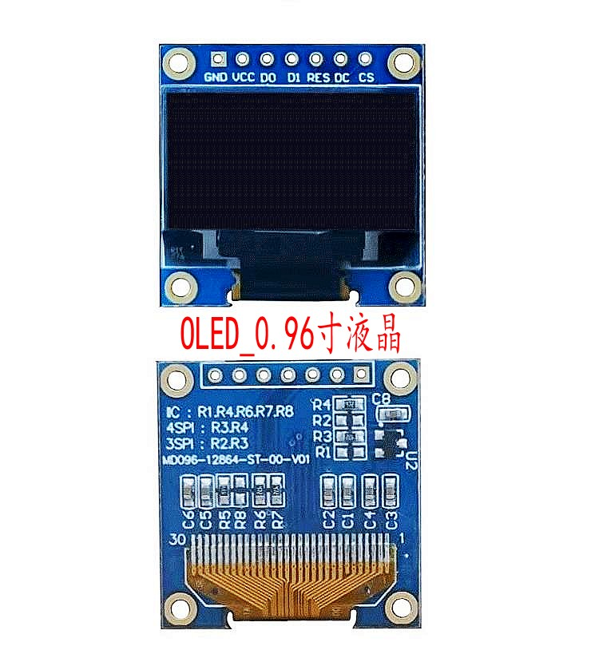
Module physical picture

